APPLICATION

B4: co-funding of development project

Maximum amount: DKK 2 million

Cover page

Danish applicant organisation (financially responsible):
Contact person for the project: | Name:  Email address:  Telephone number:
Any other Danish organisations

Any other partners from the ‘North’:
Partner organisation(s) from country of cooperation:

Title:
Country(-ies) of cooperation:

Time period: | Start date:  Click here to insert a date |  | Completion date:  Click here to insert a date |  | Total number of months:
Total budget in application to main donor:
Amount applied for (in the Disability Fund): | Total amount:  DKK | Of which, disability compensation:  DKK: |  | The Disability Fund’s contribution as a percentage of the total budget of the intervention: %
Signature of applicant organisation’s legally authorised representative:  The signature attests to the Danish organisation’s commitment to the proposed partnership and to this application for a co-funded project, and confirms that it is in conformity with the Disability Fund’s guidelines, including the financial requirements. It also confirms that the signatory legally represents the Danish organisation. | Click here to insert a date.  Date Signature of legally authorised representative  Place Name of representative (block letters)

Who is the main donor to this project?
Title of the modality or funding facility at the main donor?
Title of ’call for proposals’ or ‘funding window’:
Expected date of response from main donor

Is this a new activity and/or does it involve new partners? | Does the project involve:  ☐ New partners in Denmark?  ☐ New funding partners outside Denmark?  ☐ New ‘South’ partners in countries of cooperation?  Is this:  ☐ A new project?  ☐ A new phase or an extension of a former project supported by the Disability Fund? Indicate the case number (Danish “HP nr.”) if applicable:  ☐ A new phase of a former project funded by the main or by some other source? Indicate donor’s name, if applicable:
Is this a re-submission? (I.e. a revised version of a previously submitted application) | ☐No  ☐Yes, last submission date was on date/year:
Would you prefer the assessment of your application in: | ☐ Danish  ☐ English
Have you received advice from DPOD in relation to this application? | ☐ Yes  ☐ No
Synthesis
(Brief description of the intervention in Danish, max. 200 words. This will be used as a presentation of the project on DPOD’s website.)

Guide

The application is composed of the following parts:

Cover page: Key information about the application and applicant(s).

Part I Application text:

The application text is brief, consisting of only four main questions, since the project proposal will primarily be assessed by the main donor. Each section contains a number of questions, and each question is accompanied by a guiding text or sub-questions written on a pale green background. All text on a pale green background is intended as a guide and must be deleted before submitting the application. This will make it easier for you to keep track of the actual number of pages in part I.

TIP: You can easily delete all the text on a pale green background in one go – Open ‘home’ (startside) and find styles (typografier) – right click on the style “Heading 5”(overskrift 5) press ‘select all’ (‘vælg alle forekomster’). Now press delete on your keyboard. This can preferably be done when all text in the application has been written.

Note that the higher the amount applied for, the higher the requirements regarding the project’s professional standards as well as the applicant’s and local partners’ organisational capacity.

Part II List of annexes: Here we ask you to itemise obligatory and supplementary annexes substantiating the application. Note that annexes are not self-explanatory. Key information must therefore be referred to in the application text.

Part III Checklist: This last part consists of items to be crossed off before submission to make sure the application is not rejected on administrative grounds.

Please note that: the application should be drawn up in cooperation between the partner organisation(s) and the Danish applicant organisation. All applications must thus be prepared in a language that is shared by the Danish disability organisation and its local partner. The version for DPOD, however, must be submitted in either Danish or English.

Advice and assistance: The Guidelines for the Disability Fund, which are available at handicap.dk/internationalt-samarbejde, provide tips on the application process and presents the Disability Fund’s conditions and requirements. In addition to reading this publication, you are always welcome to contact DPOD’s advisors for guidance.

Submission of application:

The application and annexes are emailed to: ansogning@handicap.dk

See closing dates at handicap.dk/internationalt-samarbejde

I. Application text (suggested length: max 8 pages)

[The application text aims to briefly outline the planned project, and particularly to clarify its disability component and how a grant from the Disability Fund will be spent. Responses should be concise, focusing on the most relevant information.]

1.a The UN Sustainable Development Goals

Which of the UN Sustainable Development Goals are mainly being pursued by this project?

[Tick 2-3 of the boxes below indicating the goals the project is working with.]
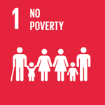☐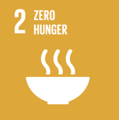☐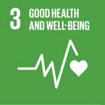☐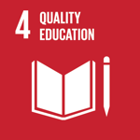☐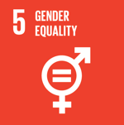☐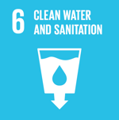☐

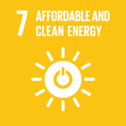☐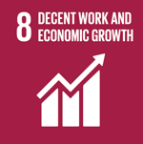☐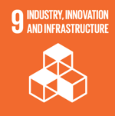☐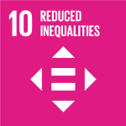☐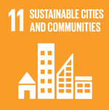☐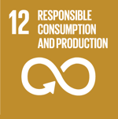 ☐

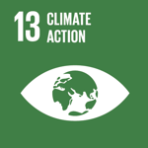☐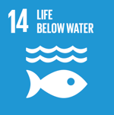☐ 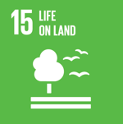☐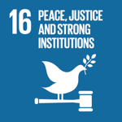 ☐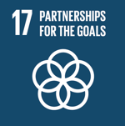 ☐

[Each Sustainable Development Goal consists of a number of more specific targets. Furthermore, all targets come with a set of indicators so as to be more measurable. Read more at: handicap.dk/internationalt-samarbejde.]

For each of the Sustainable Development Goals which have been ticked above, please specify which targets will be addressed by the project (only required if If you are applying for more than DKK 500,000).

1.b Brief project description

What is the overall purpose of the project?

How will the project bring about improvements or overcome challenges for groups or individuals with disabilities and strengthen their organisations?

[If the following is not clear from the main application / concept note attached to this application, then describe the following:

Primary target groups and other stakeholders, including the number of persons with disabilities and duty bearers you expect to reach, and the strategic partners you expect to cooperate with.

Short-term and long-term objectives of the project.]

1.c Participation in a consortium

[In the event that you form part of a consortium, the Danish disability organisation (applicant organisation), should, in principle, be the lead organisation as far as the disability component of the project is concerned.]

Does your organisation form part of a consortium?
Yes ☐ No ☐

Are you the contract holder towards the main donor?
Yes ☐ No ☐

If you are not the contract holder, explain the division of responsibilities within the consortium, including your own role.

1.d Added value of the Danish disability organisation(s)

In view of the international experience of both the Danish- organisation and the partner organisation, what are the main lessons learned that you bring to the design of this project and to this partnership?

[If a midterm review or final evaluation of a previous project has been conducted (ideally with the same partner), what were the main conclusions? Indicate the case number (Danish “HP nr.”]

What value do you expect to add to the project?

[This could include experience from the organisational and rights based work in Denmark, particular methods or tools that you use, experience from other partners in the Global South, or specific goals that you have accomplished.]

Does the activity budget (Budget line 1) include Danish man-hours ie. technical support to project activities? (See DPOD’s Financial Management Manual for rules regarding Danish man-hours.)
Yes ☐ No ☐

If yes, has the use of Danish man-hours been described in the application to the main donor annexed to this application to the Disability Fund?
Yes ☐ No ☐

If no, please describe the assignments to be covered, or annex TOR for the assignment(s) (see current rules in force in DPOD’s Budget Guide available at handicap.dk/internationalt-samarbejde).

1.e Information in Denmark

[You are encouraged to make use of the opportunity to do information work in Denmark. This could involve campaigns, posts on social media, newsletters, and communication targeted at members of your organisation and the general public. To this end, you can apply for an amount of up to 2% of total project costs (budgets items 1-7).]

Are you applying for funds to cover information work in Denmark?
Yes ☐ No ☐

If yes, briefly describe the kind of information you plan to disseminate about the intervention, your target group, expected reach and means of communication.

II. Annexes

[In this section list obligatory and supplementary annexes that substantiate the application, including budget with budget notes. Supplementary annexes serve to elaborate the application text. You should therefore remember to refer to your annexes in the actual application, which is also where the main points should be highlighted. Find templates for most of the annexes at handicap.dk/internationalt-samarbejde.]

1. Obligatory annexes

- Application to main donor (e.g. ’Concept Note’ for EU co-financing) including budget.
- ‘Guidelines for grant applicants’ from the main donor.
- Completed Budget Format B concernig the contribution from the Disability Fund..

2. Supplementary annexes
Complementary annexes may be, for instance, reports or analyses directly substantiating the objectives and rationale of the intervention. Please, only include documents that are key to the understanding or the assessment of the project.
Annex | Annex title
D.
E.
etc.

To all organisations engaged in international cooperation

In addition to the annexes above, all Danish organisations engaged in international cooperation and applying to the Disability Fund must email their latest organisational profile by the end of each year to DPOD at: ansogning@handicap.dk. It is the responsibility of the applicant to ensure that DPOD is in possession of an up-to-date version when receiving an application.

III. Checklist
The checklist is an obligatory part of the application with the aim of ensuring that all administrative requirements are met. The checklist is therefore intended as an aid in the application process to avoid having the application returned due to minor errors or omissions.

1. Application
 | Yes | Remark
All questions in the application form have been answered (cover page and Part I-II).
Part I of the application adheres to the indicated number of pages.
All explanatory text (marked with pale green background, italics and square brackets) has been erased.
A project synthesis has been written in Danish at the bottom of the cover page.
All replies have been written in the font Arial, size 11, non-bold.
The organisation’s legally authorised representative has signed the application on the cover page.

1.b Budget
 | Yes | Remark
The correct Budget Format (B) has been used.
The budget figure on the cover page of the application (“Amount applied for”) mirrors the total in the Budget Format submitted.
Budget Format, spreadsheet 1: Budget and budget notes: | Yes | Remark
Relevant budget notes have been inserted.
Budget Format, spreadsheet 2: Financing plan: | Yes | Remark
Has been completed
Budget Format, spreadsheet 3: Danish man-hours: | Yes | Remark
If the activity budget (budget line 1) includes Danish man-hours for technical support the role of Danish man-hours is well described either in the application or in an annexed TOR.
Budget Format, spreadsheet 4: Disability compensation | Yes |  | Remark
If disability compensation has been applied for, this spreadsheet has been completed.

1.c Annexes
 | Yes | Remark
Obligatory annexes have been attached – see list in Part II of the application form.
All other relevant supplementary annexes have been listed and attached.
The electronic files of all annexes have been named in alphabetic order
An up-to-date organisational profile has been emailed to DPOD within the past year.

Approved applications are uploaded to DPOD’s international website for the sake of transparency within the Disability Fund and in order to inspire others. If you do not wish your contact details to be published through this channel, please, write so to: ansogning@handicap.dk. You may at any time withdraw your consent. Read more about DPOD’s data protection and privacy policy.
Support from the Disability Fund cannot exceed 25% of the total budget.

